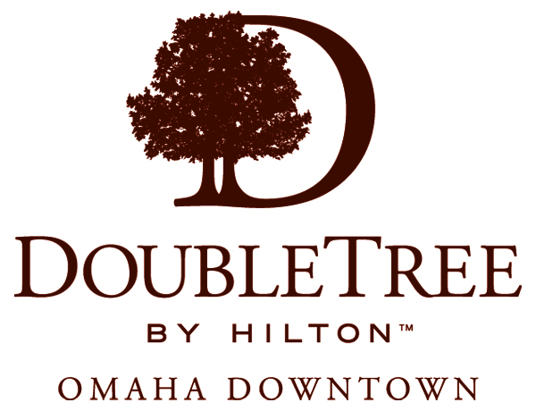
OMAHA PARK
SEVEN
ZORINSKY FEDERAL
BUILDING
CIVIC AUDITORIUM
AND MUSIC HALL
CENTRAL CITY
PARKING GARAGE
FIRST NATIONAL BANK
PARKING GARAGE
FIRST NATIONAL BANK TECHNICAL CENTER
N
CAPITAL STREET
17TH STREET
DAVENPORT STREET
DODGE STREET
18TH STREET
16TH STREET
PARKING
FIRST NATIONAL
BANK
MAIN ENTRANCE
PARKING
PARKING
The First National Bank parking garage, adjacent to the Doubletree Hotel is open 24 hours. The Doubletree Hotel is accessible via the
elevator, press Level (2), exit the elevator into the garage, turn right to access the hotel lobby. The cost is $10 per day.
Central City parking garage is open 24 hours. Public parking is available on the 7th floor..
The Doubletree Hotel is accessible via the elevator and the underground tunnel.
Press Level "B" and follow the tunnel walkway into the
First National Bank corridor. Continue past the elevators and escalators to the end of the corridor and turn left. Enter the Doubletree
Hotel, proceed to the elevator, press the Lobby button.
1
1
2
2
15TH STREET
CHICAGO STREET
I-480
WEST
I-480
EAST

